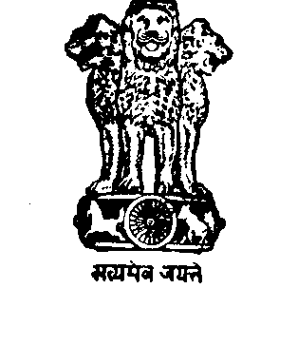
GOVERNMENT OF WEST BENGAL
PANCHAYAT & RURAL DEVELOPMENT DEPARTMENT
JESSOP BUILDING, 1ST FLOOR
63, N.S. ROAD, KOLKATA – 700 001.

No. SPRD-55(18)-10/RD/P/SGSY/20M-6/08 Date : 08.01.2010

From : Principal Secretary to the
Govt. of West Bengal.

To : The District Magistrate – All.

Sub : Inclusion of left out families in RHS database.

Madam / Sir,
Queries have been raised from a few districts that the present order of this department does not allow inclusion of new families, whose names do not appear either in the APL list or in the BPL list. The Para 4 of the last order in this respect (Memo No. SPRD-1537(18)-09/RD/P/SGSY/20M-6/08 dated, 24.11.2009) categorically prescribed the procedure for inclusion of new families by capturing data in Form II. In view of the urgency to include those families in the RHS database so that they get Ration Cards as appropriate for each family, the applications for the families praying for inclusion in the list should be disposed of urgently. The particulars of the families (including all members) should be captured in the prescribed format through field enquiry and all those should be compiled as soon as possible, preferably before the issuance of new Ration Cards. The database of all these new families should be forwarded Block-wise to this end for inclusion of those families in the appropriate database (APL or BPL). There have been cases where names of families already existing in the Household list have been entered again as a new family, Block office should do necessary scrutiny to ensure that there should not be duplication while forwarding names of new families. There could be cases in which the families have been split and the names of a few / all the members are already there in the database of the original family. In such case the applicant family should mention the name of the head of the family to which they belonged with address for tracking the family in the database and editing the same. Such editing by deleting names of outgoing members will be done by the Block Development Officer and names of those who have left and constituted new families should be deleted for being entered in the database as a new family. However, the inclusion will be done centrally after reaching the data in the prescribed format as already circulated.

Yours sincerely,

Principal Secretary to the
Govt. of West Bengal.

No. SPRD-55(18)/1(2)-10/RD/P/SGSY/20M-6/08 Date : 08.01.2010

Copy forwarded for information and necessary action to :

1. The Principal Secretary, Food & Supplies Department, Govt. of West Bengal, Khadya Bhavan, 11A, Mirza Ghalib Street, Kolkata – 700 087.

2. The Principal Secretary to the Chief Minister, Govt. of West Bengal, Writers’ Buildings, Kolkata – 700 001.

Principal Secretary to the
Govt. of West Bengal.

